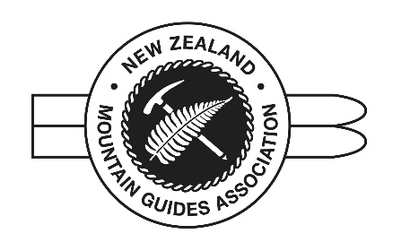
NEW ZEALAND MOUNTAIN GUIDES ASSOCIATION (Inc)
www.nzmga.org.nz | info@nzmga.org.nz | ph: (+64) 021 222 1022
PO Box 10, Aoraki Mount Cook 7946, New Zealand

MEDICAL REPORT
NEW ZEALAND MOUNTAIN GUIDES ASSOCIATION

PRIVATE AND CONFIDENTIAL
INFORMATION FOR MEDICAL PRACTITIONERS
Your patient has applied to enter the training scheme which leads to the qualification of Mountain Guide. It is important that the candidate is fit and able to be in this role.
In general, a Mountain Guide must have a good level of fitness both physically and mentally. The profession demands that he or she sustain physically demanding work for long hours in a potentially dangerous environment, often subjected to extreme temperatures, and high altitude.
Your opinion as to the health of the candidate is sought
Name of Patient:
Address:

Date of Birth:
Are you the candidate’s usual doctor?
For how many years do you hold records on this candidate?
When did the candidate last consult with a doctor?
Does the candidate suffer from any serious conditions such as Epilepsy or other significant neurological conditions, Diabetes, Heart or Respiratory disease, Meniere’s disease, conditions affecting the musculoskeletal system, serious psychiatric illness, addiction to alcohol, drugs or other harmful substances? Is there any history of eye disease or surgery to the eyes?
NO YES If Yes, please complete the following section
If YES above, please give details below with dates: Please include details of hospitalisations and time off work.

Is the candidate on any regular medication? Please give details.

PHYSICAL EXAMINATION
SPECIFICS
HEIGHT |  | WEIGHT
BMI
CARDIOVASCULAR
RESTING PULSE RATE AND RHYTHM

BP
HEART SOUNDS
PERIPHERAL PULSES
RESPIRATORY EXAM
PEAK FLOW
SENSORY
VISION (CORRECTED/ UNCORRECTED)
HEARING
CRANIAL NERVES
BALANCE AND COORDINATION
ABDOMINAL EXAM
MUSCULOSKELETAL, including significant joint or mechanical condition
MENTAL STATE

GENERAL HEALTH

DECLARATION (delete as appropriate)
I consider the candidate to be physically and mentally fit for the profession of Mountain Guide

I consider the candidate to be physically and mentally fit with these qualifications

I suggest a further specialist opinion be sought to clarify the following concerns:

I consider the candidate to be unfit for the profession of Mountain Guide

SIGNED:
TITLE/QUALIFICATIONS:
DATED:

